Exp. No: 13
Analysis and Plotting of Linear, Circular and Elliptical Wave Polarization
Test Case (i) – Classification of the Polarization State
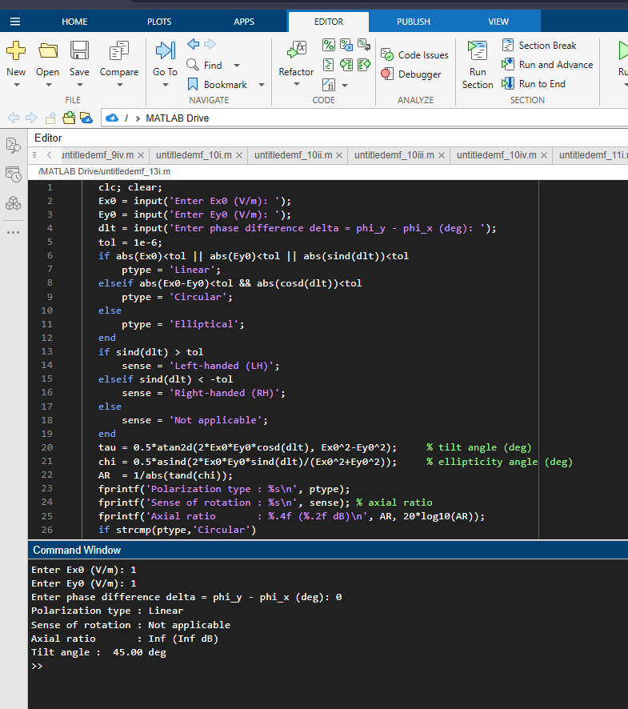
Test Case (ii) – Plotting the Polarization Ellipse
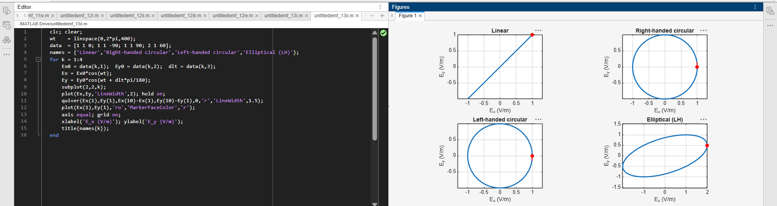

Test Case (iii) – Poynting Vector for Linear and Circular Polarization
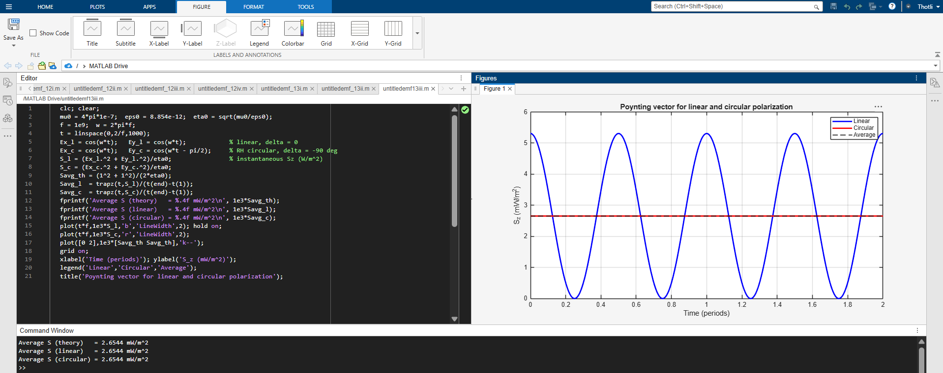
Test Case (iv) – Three-Dimensional View of the Field Vector along the Direction of Propagation


